**Implementation of different types of LAN topology with IP addressing using PT**

**Objectives:**

* Design the following topology in Packet Tracer.
* Subnet each of the network with the IP and complete the following table.
* Assign the appropriate IP into each of the network.
* Add one more PC to each of router and assign IP.
* Test connectivity between PC in a router.

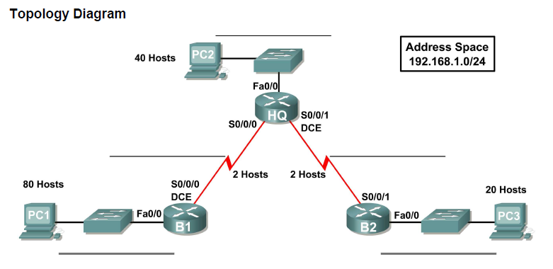

Subnet Table

|  |  |  |  |  |
| --- | --- | --- | --- | --- |
| Subnet | Assignable Adress Range | Subnet Mask | Subnet Address | Broadcast Address |
| First subnet (80 hosts) | 192.168.1.1/25  192.168.1.126/25 | 255.255.255.128 | 192.168.1.0/25 | 192.168.1.127/25 |
| Second subnet (40 hosts) | 192.168.1.129/26  192.168.1.190/26 | 255.255.255.192 | 192.168.1.128/26 | 192.168.1.191/26 |
| 3rd subnet (20 hosts) | 192.168.1.193/27  192.168.1.222/27 | 255.255.255.224 | 192.168.1.192/27 | 192.168.1.223/27 |
| 4th subnet (2 hosts) | 192.168.1.225/30  192.168.1.226/30 | 255.255.255.252 | 192.168.1.224/30 | 192.168.1.227/30 |
| 5th subnet(2 hosts) | 192.168.1.229/30  192.168.1.230/30 | 255.255.255.252 | 192.168.1.228/30 | 192.168.1.231/30 |

Addressing table

|  |  |  |  |  |
| --- | --- | --- | --- | --- |
| Device | Interface | IP address | Subnet mask | Default Gateway |
| HQ | Fast ethernet 0/0 | 192.168.1.129/26 | 255.255.255.192 | N/A |
| Serial 2/0 | 192.168.1.225/30 | 255.255.255.252 |
| Serial 3/0 | 192.168.1.229/30 | 255.255.255.252 |
| B1 | Fast ethernet 0/0 | 192.168.1.1/25 | 255.255.255.128 |  |
| Serial 2/0 | 192.168.1.226/30 | 255.255.255.252 |
| B2 | Fast ethernet 0/0 | 192.168.1.193/27 | 255.255.255.224 |  |
| Serial 3/0 | 192.168.1.230/30 | 255.255.255.252 |
| PC1 | N/A | 192.168.1.10/25 | 255.255.255.128 | 192.168.1.1/25 |
| PC2 | N/A | 192.168.1.130/26 | 255.255.255.192 | 192.168.1.129/26 |
| PC3 |  | 192.168.1.200/27 | 255.255.255.224 | 192.168.1.193/27 |